## Case 1

$$\frac{dΦ}{dt} =βΦ - ωΨ - Φ(Φ^{2}+Ψ^{2})$$

$$\frac{dΨ}{dt} = ωΦ +βΨ - Ψ(Φ^{2}+Ψ^{2})$$

Looking at the zero diffusion case this isn’t going to work. There needs to be a change in period over beta. Without the change in period the diffusion (calculated by a difference in concentration over space)will always be zero. **The wave will not propagate**. It will only flatten towards the bifurcation.

w = 0.5;

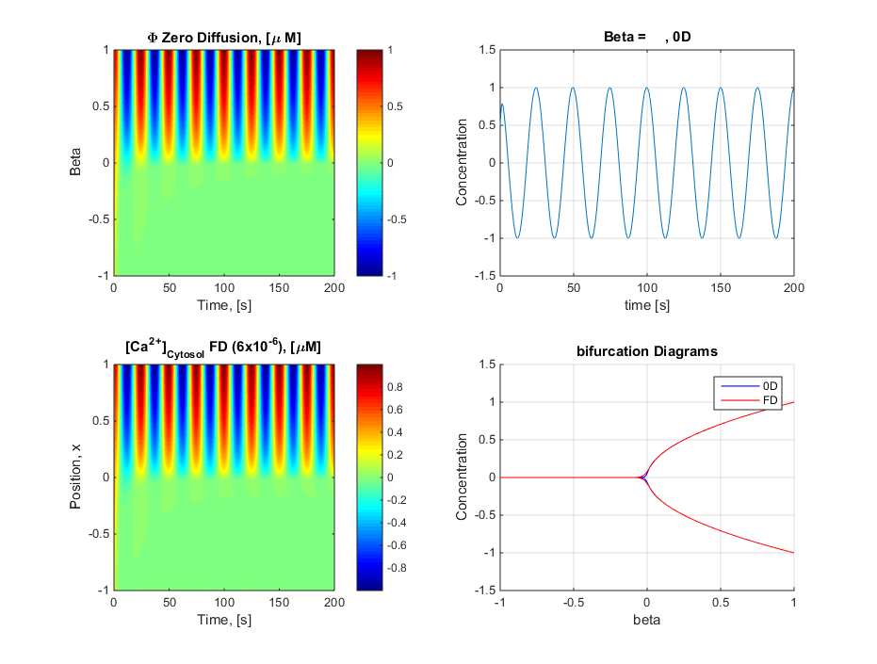

Limit cycle contour changing beta, Anti Clockwise direction

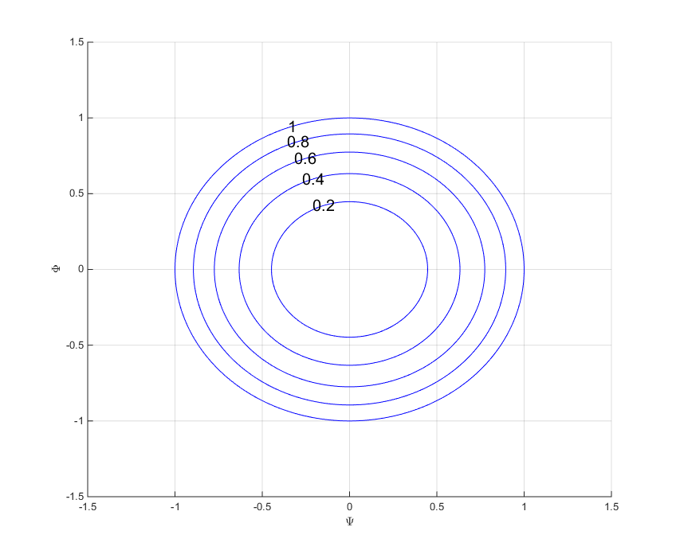

## Case 2

$$\frac{dΦ}{dt} =βΦ -βΨ - Φ(Φ^{2}+Ψ^{2})$$

$$\frac{dΨ}{dt} = ωΦ +βΨ - Ψ(Φ^{2}+Ψ^{2})$$

This is a symmetrical wave with a changing period; increasing towards the bifurcation. With a symmetrical wave it will not penetrate. … As expected results

w = 0.5;

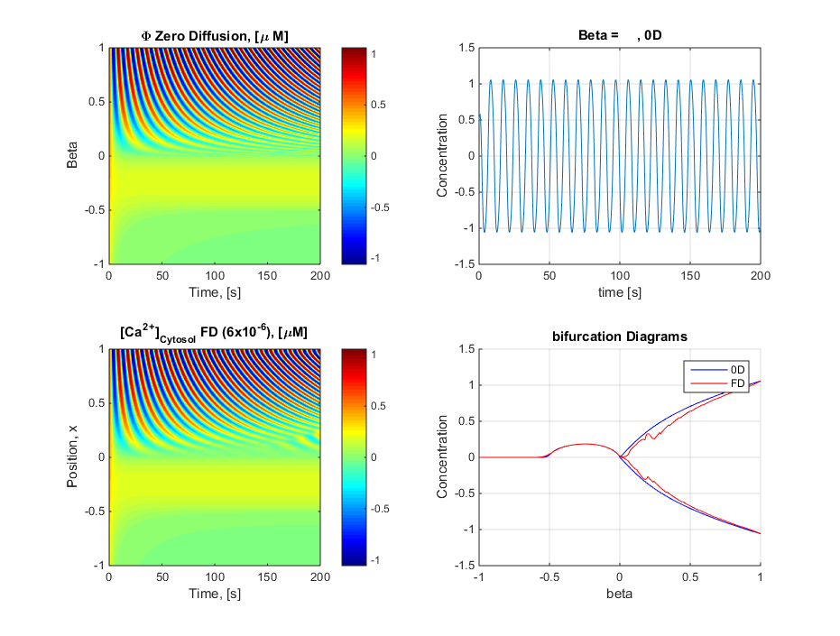

Limit cycle contour changing beta, Anti Clockwise direction

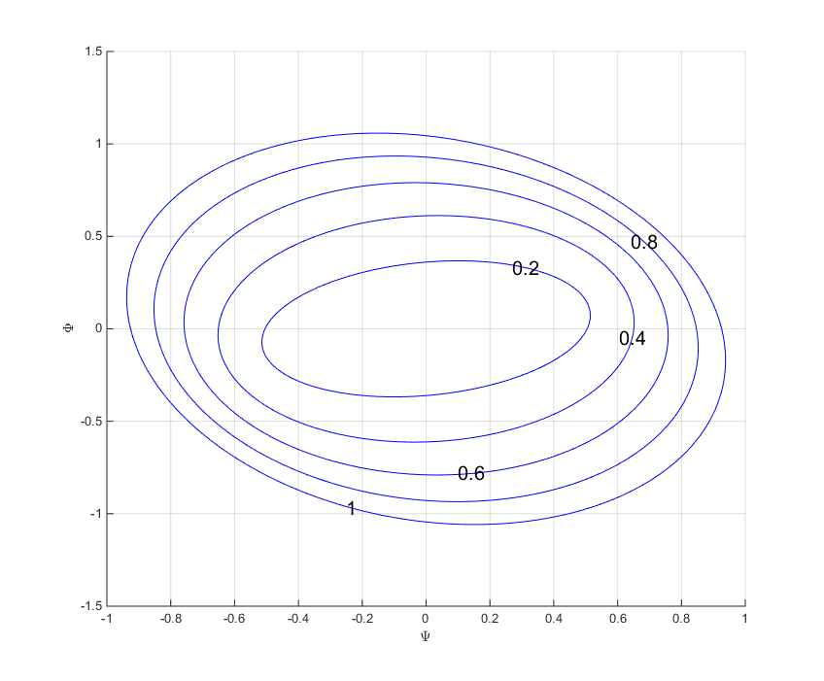

I Hadn’t thought of making a limit cycle for the diffusion case for the case 1 it is the same for case 2 it is different

Diffusion limit cycle

